Financial and Accounting
Procedures Manual
For
PREVENT

TABLE OF CONTENTS

1.0 OVERVIEW OF ACCOUNTING AND PROCEDURES MANUAL 3
2.0 OVERVIEW OF THE FINANCE AND ACCOUNTING DEPARTMENT 4
3.0 FINANCIAL REPORTING 7
4.0 BANK ACCOUNTS 13
5.0 ACCOUNTING DOCUMENTS AND PROCEDURES 14
6.0 PETTY CASH MANAGEMENT 14
7.0 ACCOUNTING FOR IMPREST 16
8.0 PURCHASING /PROCUREMENT POLICY 17
9.0 CASH RECEIPTS 21
10.0 RECEIPT OF GOODS AND PAYMENT 21
11.0 SAFE POLICY 22
12.0 CHEQUE SIGNATORY AUTHORITY POLICY 22
13.0 CHECKLIST OF END OF MONTH PROCEDURES 22
14.0 EMPLOYEE CONTRACTS, TIMESHEETS AND PAYROLL 23
15.0 TRAVEL AND PER DIEM 24
16.0 MANAGEMENT OF SUBAGREEMENTS 27
17.0 MANAGEMENT OF OFFICE SUPPLIES 27
18.0 PHYSICAL INVENTORY. 28
19.0 PROJECT VEHICLE AND EQUIPMENT USE 28
20.0 AUDIT POLICY 29
21.0 BUDGET APPROVAL POLICY 29
22.0 DONOR’S POLICY AND GUIDELINES 29
23.0 SAMPLE ACCOUNTING POLICIES 29
24.0 GLOSSARY OF TERMS 31
Appendix 1: Ethics Policy 37
Appendix 2: Cash Receipt Form 41
Appendix 3: Purchase/Cheque Requisition 42
Appendix 4: Purchase Order 43
Appendix 5: Petty Cash Voucher 44
Appendix 6: Petty Cash Count Form 45
Appendix 7a: Vendor Quotation Sheet ($500-$2500) 46
Appendix 7b: Bid comparison > $2500 (Best price & Best Value) 47
Appendix 8: Time Sheet 49
Appendix 9: Salary Sheet/Labor Distribution Sheet 50
Appendix 10: Request for Travel Advance 51
Appendix 11: Travel Expense Reimbursement Form 52
Appendix 12: Inventory/Fixed Asset Register 53

1.0 OVERVIEW OF ACCOUNTING AND PROCEDURES MANUAL

1.1 Purpose

PREVENT’s continued service depends on its ability to safeguard and manage effectively and efficiently all donor funds (including locally generated income) entrusted to it. Central to this goal is a sound structure of financial management and control to maintain both integrity and confidence.

This Manual describes the financial policies and procedures for ensuring accountability on effective and efficient use of funds. The procedures are aimed to give Management (including the Board of Directors) accurate, complete and timely financial information.

Any deviations from adhering to the procedures contained in this Manual by PREVENT staff should be in writing and approved by the Executive Director.

The implementation of this Manual is essential for the successful delivery of PREVENT’s services as we conduct our activities morally, ethically, and in the spirit of public accountability and transparency, and in conformity with applicable laws and regulations and practices common with responsible organizations.

The principles and suggested procedures in the Manual reflect systems currently in operation, or being implemented by PREVENT and those expected to be adopted by its sub-partners.

This Manual has been designed to suit specifically the accounting and financial management practices at PREVENT, and the general principles and essential features are applicable to all resources no matter their source (e.g. Cooperative Agreement from CDC, subaward with another partner, or locally received funds).

This Manual is not exhaustive but provides a framework for accounting and financial procedures within the organization.

As circumstances and requirements change the manual should be reviewed and updated annually to take into account potential new donor regulations, tax law regulations, as well as new developments in the accountancy profession and changes in the organization.

1.2 Importance of Financial Accountability

The ability to provide accurate, complete and timely financial information enables compliance with the rules and regulations of donors and other partners reporting requirements, as well as adhering to generally accepted accounting principles (GAAP). This information also assists management to plan and coordinate their programmes effectively.

The guidance in this Manual should be used in conjunction with other policies and procedures specified from respective donors.

1.3 Scope

This Manual should be used across the organization to guide the handling of finance functions. It provides guidance on all financial procedures and reporting requirements.

The usefulness of any manual is in its applicability to provide guidance. As the transactions of PREVENT evolve, diverse and increase, this Manual must remain relevant, therefore it is critical that management ANNUALLY review and revise this manual as needed.

1.4 Cooperative Agreement Signing Authorities

The Chairman or the Executive Director should sign all cooperative agreements

2.0 OVERVIEW OF THE FINANCE AND ACCOUNTING DEPARTMENT

2.1 Financial Records

Financial records include all source documents (budgets, invoices, vouchers, bank statements, credit advice, journals, cheques, receipts and any other documents which serve as evidence of financial transactions).

2.2 General Responsibilities

PREVENT requires all of its employees to abide by the foregoing standards of ethical behavior in their dealings with its suppliers, consultants, sub grantees, subcontractors, and government. Employees of PREVENT should not solicit for any funds, gifts or any favours from a prospective vendor, sub grantee or any other business partner. Attached as Appendix 1 to the Manual is PREVENT’s ethics policy which ALL staff are required to sign on an annual basis. (Copies of the signed ethics statements will be kept within personnel files).

Staff are also required to report any violations of these standards to the Executive Director and Board Finance Subcommittee.

The Executive Director has overall authority and oversight of all funds.

  - Finance and Accounting Responsibilities

2.3.1 Finance /Operations Manager

Please note: In absence of a designated Finance/Operations Manager, PREVENT may subcontract out with a licensed Accounting Firm for financial management assistance and if these services are subcontracted, all of the duties specified below will apply to the responsibilities of the subcontracted firm / individual.

Primary functions
- Ensure that the financial system runs properly in order to process financial information and generate accurate reports.
- Ensure that internal controls are enhanced and maintained at an acceptable level,
- Manage risks affecting PREVENT’s assets and make sure risks are maintained at a lower level.
- Ensure that financial policies, procedures and donor compliance requirements are adhered to expected standards
- Ensure that internal and external financial reports are prepared and disseminated within deadlines
- Ensure there is enough cash on hand and vendors are paid promptly
- Responsible for all aspects of cash management including:
- Monitoring receivables, billing staff and collection of debt and managing pre-payments.
- Lead, direct, mentor/coach, appraise and supervise the other finance staff

2.3.2 Bookkeeper / Admin Assistant

Primary functions
- Ensure that payment package is complete and accurate before processing.
- Ensure that charge codes are in agreement with Program Managers’ approval and the organization’s chart of accounts.
- Ensure that vendors/Suppliers, Staff and Sub-recipients’ cheques are prepared and paid on time.
- Maintain petty cash ledger and prepare petty cash replenishment.
- Prepare cash receipt voucher for cash collected and deposited to bank account.
- Ensure that copy of cash receipt and bank deposit must be attached with the Cash Receipt voucher.
- Ensure that the Petty cash replenishment is prepared the moment the paid cash is 75% of the cash float.
- Prepare cash and check deposit slip and give it to the agent for banking on a daily basis.
- Cash collected from staff travel advances and other receipts must be banked within the next business day.
- Ensure that all cash at hand must be locked in a safe overnight and on weekends.
- Maintain safe ledger and keep the first key of the safe.
- Work closely with Administrative officer on physical counting of assets, stocks and property.
- Prepare a stock count report on a monthly basis
- Manage the asset register
- Prepare cash receipt vouchers.
- Retrieve documents needed for Audits
- Ensure that soft copy and hard copy month end closing packages are filed properly and done within the due dates
- Ensure that data is posted on a daily basis, and that the financial information is processed accurately and reliable reports are generated timely
- Ensure that internal financial reports are generated accurately and disseminated timely.
- Perform systems analysis to identify any irregularities (such as wrong posting) and propose immediate corrective actions to the finance manager

2.4 Internal controls

Internal accounting control consists of the PREVENT’s plan, procedures and records to assure the reliability of financial reporting as well as safeguard the assets of the organization.

An effective internal control structure includes a series of checks-and-balances required for the appropriate recording and authorization of transactions and ensures that access to assets is limited to authorized personnel. Each transaction should be divided into component tasks completed by different staff members in order to increase the likelihood of detecting unintentional errors and prevent misappropriation of PREVENT’s assets.

As an example, the person who approves vouchers for payment should not prepare or sign cheques.

The following chart includes other examples of the appropriate segregation of duties:

Finance Officer Who: | Should Not:
*Prepares vouchers | *Approve Vouchers
*Prepares Cheques | *Sign Cheques
*Has access to Blank Cheques | *Post Payments
*Receives Cash | *Bank or deposit the cash receipts at the bank
*Is responsible for the physical | *Perform the physical
security of Assets | inventory of Assets
*Prepares Bank Deposits | *Reconcile Bank Accounts
*Prepares payroll | *Distributes payroll payments
*Maintains Driver Logs | *Monitor Fuel Usage

The following four basic tests of completeness, validity, accuracy and maintenance should be consistently applied to all transactions

2.5 Completeness

Each element of a transaction must be documented, approved and recorded.
For example: A cash payment to a worker requires the signature of the worker or other proof as evidence of payment.

2.6 Validity

Is the disbursement made to a verifiable vendor or employee?
Is there such tangible proof, such as a vendor’s receipt, purchased item, to confirm that the item was received or the services performed?

2.7 Accuracy

Is the amount recorded as received or disbursed correct?
Are all relevant charges recorded?

2.8 Maintenance

After a payment has been approved for payment and recorded, it should be impossible to make changes, such as addition of a zero to the amount or changing the payee name, or in deed using the same documents for other double payments. All documents after use must be stamped PAID to avoid re-use.

Close supervision by the Finance/Operations Manager and oversight by the Executive Director are vital to ensure that control systems are working and that weaknesses are identified and corrected.

3.0 FINANCIAL REPORTING

3.1 Overview

Financial reports are summaries of the information found in financial records for a given time period or as of a certain date. Financial reports also provide information on the financial status of a project including project income/costs, cash flows and trial balance. Financial reports may also include sufficient background information to support the data included in reports.

3.2 Financial Transactions

For the purposes of this Manual, a financial transaction is any occurrence, which results in an inflow/outflow of funds or has any effect on the organization’s assets and liabilities.

All financial transactions will be accounted for accurately and properly. No undisclosed or unrecorded funds or assets will be established or maintained for any purpose.

No borrowings on behalf of the organization are to be made from any lending institution or individual without the prior written authorization from the Board of Directors.

For any cost to be allowable under specific grant agreements, the costs must meet the following general criteria:

- Be reasonable for the performance of the grant agreement and allocable thereto
- Be consistent with organizational policies and procedures
- Be determined in accordance with generally accepted accounting principles (GAAP)
- Conforms to any limitations or exclusions set forth in the principles or in the agreement as to types or amount of cost items, and
- Be adequately supported and documented.

A cost is reasonable if in its nature or amount it does not exceed that which would be incurred by a prudent person under the circumstances prevailing at the time the decision was made to incur the costs. In determining this, it should consider whether the cost is of a type usually recognized as normal and necessary for the organization’s operations.

All costs incurred should be allocable to projects i.e. its activities or benefits can be distributed reasonably to that specific project.

Transactions processed using the respective source documents must be stamped processed/paid to avoid duplication.

PREVENT uses an accrual (preferred) or cash based accounting system to recognize income and expenditure.

3.3 Procedures for Receiving Funds

3.3.1 Objective of a Receipting System

The objective of a receipting system is to ensure that all funds donated/collected are fully accounted for in financial records and reported to the donors.

    - Main strategies to Achieve the Objective

In order to ensure that funds are fully accounted for in financial records, the following strategies should be applied:

- Effective control of accounting documents (receipt books, cheque books). A receipt book should be serially numbered and have three copies:
- Original goes to the payer
- The second copy is filed in Accounts department and
- The book copy remains as a permanent record. A receipt is a proof of payment and payer should obtain one.

*Attached as Appendix 2 to the Manual is PREVENT’s cash receipt slip which should be serially numbered and in triplicate.

- The cashier should receive all monies, issue a receipt for all funds received, and reconcile all funds received with amounts to be banked the following day at the end of each day.

- Cash disbursements must not be made from cash received. All cash received must be banked and supported by an official bank deposit slip.

- Cash receipts should not be mixed up with the petty cash fund

- Strictly all receipts issued should be recorded and analyzed in the cash books for onward posting to the ledgers at the end of each month.

- All bank transfers (direct credits) must be authorized by designated signatory and should immediately be recorded in the cash book. Prompt recording and analysis of receipts in the cash book shows up at the earliest point the levels of funds received and allow spot check of cash on hand.

- All original documents should be systematically filed in box files and made readily available for any prompt audit. The Finance/Operations Manager should be fully responsible for this receipting system and should therefore check the bank reconciliation to separate the duties to show transparency of the system.

- All receipt books should be recorded in a Register kept by the Bookkeeper. Only the Bookkeeper will be responsible for the issuance of the receipt book for use. The Register should show:
- Serial numbers of each receipt book
- Date when receipt book received from the printer
- Name and signature of staff entering the new receipt books into the Register
- Date the receipt book issued for use and
- Name and signature of staff requisitioning the receipt book for use.

  - Procedures for Payments

    - Objectives of Payment Procedures

The objectives of a good payment procedure is to ensure that disbursement of money is and can be proved to be legitimate and transparent and in accordance with the budget.

Accounts Staff should ensure that the details from the source documents are processed correctly in the cashbook. Each disbursement will be supported by:

- purchase requisition (see appendix 3 for example)
- purchase order (see appendix 4 for example)
- voucher authorizing payment signed by at least 2 authorized signatories
- completed cheque signed by authorized signatories
- supporting vendor’s invoice
- a receiving report and
- other independent source materials.

    - Strategies to Achieve a Good Payment Procedure

The following strategies will be applied to achieve this objective:

- All payments should be authorised by the Executive Director. When an invoice is received, it should be matched with the purchased order and checked for calculations and depending on the correctness, a payment voucher will be raised. The Finance Manager should ensure that all procedures and checks have been followed and all supporting documents attached before a payment voucher is sent to the Executive Director for final authorisation.

- Before any payment is made, the Senior Finance Officer must ensure that there are sufficient funds in the bank account.

- Payments should be posted promptly to the cash book and to the general ledger.

- Paid vouchers represent an essential means of supporting and explaining a payment as well as evidence that the necessary approval was given and procedures followed before making a payment and that voucher number and order are available for future reference.

There are two types of paid voucher, as follows:

- Fully acquitted - These vouchers have all the necessary supporting documents; and

- Not adequately acquitted - The vouchers which lack some of the necessary supporting documents mentioned above. They should be kept and filed separately from the fully acquitted vouchers and reviewed frequently to ensure that, in due course, all are fully acquitted and filed.

- Additional documentary evidence will be required under d (ii) above for such expenditure as workshop allowance, training allowance and field visits. Some of the evidence needed will include:

- workshop allowance – signed attendance list, showing amount paid to each participant, names and Passport number of each participant;

- training allowance – name of training institute, rate per period and amount paid to the candidate, duration of the course and Passport number of the candidate; and

- field visits – authorised signature of the field visit by the Executive Director, amount paid, name and Passport number of the traveler. It is recommended that the amount be given to the officer traveling as a travel advance to be accounted for on return.

- All vouchers should be filed sequentially and kept in a secure location. The removal of payment vouchers from their files and the office in which they are kept should be discouraged at all times. If it is necessary for a payment voucher to be taken away it should be signed for in a register

- An additional safeguard is to only allow whole files to be taken and not individual vouchers

- To good financial regulations, payment vouchers must be preserved for a period of six years, or until audited, or in a court case, until the case has been settled, if this is later than six years.

3.4.3 Cheque Issuing

Cheques should not be written until the payment voucher has been authorised. The cheque should be entered in the cashbook at the time that it is drawn.

The cheque should not be drawn unless the cash book indicates that funds are available to meet it. It is illegal to make payments if funds are not available.

After the cheques have been signed they should be entered in the cheque register which is maintained in cheque number order with columns, showing the name of the payee, the amount, date drawn, name and signature of person collecting it.

The drawn cheque should be sent for signing with the payment voucher and the supporting documents.

They should always be two panels of cheque signatories:

a) PANEL A - The Executive Director
b) PANEL B - The Finance Manager or Bookkeeper

Changes in authorized signatories require the approval by the Partner’s highest level of authority.

Notification of change of signatories (adding or removing) must be communicated to the bank in writing, and the letter must state the reasons. Copy of this letter will be kept in the project’s file for future verification. Copy of all bank correspondence letters should bear the bank’s stamp (and date) as a confirmation of receipt.

3.5 Monthly financial reports

The monthly financial reports will cover transactions on a period basis starting on the first day and ending on the last day of each reporting period.

The monthly financial reports currently include:
- cash book
- budget summary
- expenditure summary
- bank reconciliations

    - Cash book

Shows the dates, all the cheques in chronological order including cancelled cheques, bank transfers, details of payment, amount of each receipt and payments, running bank balance and extended columns for posting these amounts according to the budget lines

    - Budget summary

Shows how much has been spent and how much is remaining for each budget line item.

3.5.3 Expenditure summary

Within five working days after the end of each month, accounts clerks assigned to specific projects shall submit an expenditure summary to the Accountant who will review them within 48 hours after which the specific Bookkeeper will submit the reports to the programme manager and hold discussions with them to make sure they understand it and also to look at any expenditures that are likely to overrun the budget limit and to look at activities where there has been no or low expenditure which can be an indicator that certain budgeted activities are not being carried out.

    - Bank reconciliations

3 days after the bank statements are received, the accounts clerks assigned to specific projects will finalise the accounts, do the bank reconciliation and submit the bank reconciliations for checking and signing off.

3.6 External reporting

The accounting staff will be aware of all donor reporting requirements including deadlines and will ensure that all such reports are submitted to the Executive Director at least 5 days before the reporting deadline and are ready to be submitted to the Donor.

4.0 BANK ACCOUNTS

All requests to open other bank accounts should be approved by the Board Chair and Executive Director.

Each major donor should have a separate dedicated bank account. A register of all the bank accounts should be maintained and kept up to-date by the Accountant. It should have the following details:

- name of account
- name of bank
- date the account was established
- currency, account number
- interest/non interest bearing
- source of funds and
- Signatories and signing arrangements.

4.1 Procedures to adhere to when performing bank reconciliations

Bank reconciliations should be done on a monthly basis and these must be duly signed for by at least two different people.

Some of the normal standard routines to be followed regarding bank reconciliations are as follows:

- Ensure that all bank statements for each bank account are at hand before attempting the reconciliations
- Details from the source documents are processed correctly in the cash book to minimize time spent on the bank reconciliation
- References on the Cash book must be consistent with those that appear on the source documents
- Journalize bank debits/credits in the same month they occur
- Review outstanding cheques older than three months
- Use reference appearing on the bank statement to cross-reference outstanding items on the reconciliation
- Investigate long standing items on the reconciliation and if necessary write back items that are not likely to be cleared (Cheques that are outstanding for more than 6 months are regarded as stale and must be reversed)
- Once the reconciliations are complete, they should be signed off at least by the Accountant, paying particular attention to long standing deposits and cheques if any
- Bank statements must be filed together with the bank reconciliations
- Bank reconciliations should be written in ink and not pencil to minimize erasure.

5.0 ACCOUNTING DOCUMENTS AND PROCEDURES

The Bookeeper will maintain the following accounting documents.

5.1 Cheque Authorization Form

There will be a cheque request form for each cheque that includes the following information:

- Name of Payee
- Description
- Voucher number
- Cheque number
- Project Number to indicate which project(s) the cheque should be charged
- Amount and the signature of the person collecting the cheque.

The main purpose of the voucher system is to ensure there is a record in place that provides evidence of which project checks are to be charged to, that checks have been collected by the respective vendors and also to satisfy donor requirements.

An example of a cheque authorization form can be found in Appendix 3.

6.0 PETTY CASH MANAGEMENT

6.1 Overview

Expenditure for small recurring items may be paid for from Petty Cash. A member of staff shall be appointed at respective centres in consultation with the Accountant to handle petty cash. Such an officer will be responsible for:

- Preparing the Petty Cash Voucher
- Maintaining a Petty Cash Register that records all petty cash transactions
- Filing all supporting documentation for petty cash transactions
- Reimbursing the petty cash float

Petty cash float of (Organization to decide on amount) shall be clearly stated in the letter to the official handling petty cash.

The letter should indicate what items are authorized by PREVENT for the particular program to be paid from petty cash and any prior authorization needed for any disbursement, for example, Administration Petty cash allowable items are:

- Daily newspapers
- Tissues
- Sugar
- Tea leaves
- Soap etc.
.
Any expenditure that does not fall under the above mentioned categories will have to receive prior authorization from the Accountant or his/her designee.

The Accountant should sign off all the above expenditure not requiring prior authorization at the end of each day.

Program managers or the Accountant should not be handling petty cash.

An example of a petty cash voucher form can be found in Appendix 5 and an example of a petty cash count for can be found in Appendix 6.

6.2 Replenishing Petty Cash

Petty Cash will be replenished for the exact amount of expenditure incurred when more than 75% (organization can decide limit) of the petty cash float has been spent. A cheque will be issued in the name of (name of petty cash custodian) for the amount of replenishment submitted.

6.3 Petty cash management

The Bookkeeper should ensure that all petty cash vouchers are sequentially numbered and show the amount disbursed purpose of disbursement and signed by both the Accountant and recipient.

Receipts and any refunds to petty cash should be handed back to the Bookkeeper within a day of the initial disbursement. Receipts and the approved petty cash voucher should be attached together as evidence of the transaction.

The petty cash box should be kept in a safe place with access restricted and only allowed to the responsible person.

All petty cash documents i.e.: petty cash slips and invoices must be cancelled with a “PAID” stamp

Only payments less than 10% (organization can decide %) of petty cash ceiling will be paid from petty cash. Any payment in excess of this amount will be paid for by cheque.

They should be no IOU in the petty cash box and if this occurs, the petty cashier should be sternly warned in writing and dismissed on second occurrence of the IOU in the cash box.

6.4 Unannounced Petty Cash Controls

Spot checks (conducted at least 4 times a year) should be carried out by the supervising officer, and any discrepancies should be explained. The spot checks should verify the following:

- Petty cash float less (minus) any petty cash vouchers on hand should be equal to petty cash available. Any discrepancies should be explained.
- The spot checks should include checking whether the vouchers have proper authorization, proper necessary supporting documents and any reasons for non compliance or delay in compliance
- The Accountant also has the right to carryout these spot checks and should do so at least twice a year.

7.0 ACCOUNTING FOR IMPREST

7.1 Definition of Imprest

An Imprest is an amount of money advanced for a specific short-term purpose which must be accounted for immediately that purpose has been satisfied. It is given to an officer rather than direct payment to supplier.

7.2 Objective of Imprest Procedures

To ensure that all amounts advanced for specific short term purposes are properly authorised, and promptly accounted for on completion of the activity.

7.3 Main Strategies to Achieve the Objective

In order to meet this objective the following strategies are recommended:

- Control over the issue of Imprest
- Appropriate retirement procedures
- Prompt and accurate accounting
- Control to ensure prompt retirement

No person shall be issued with Imprest when there is another Imprest outstanding in her/his name.

It is important that all expenditure is accounted for promptly and properly in full, and that an Imprest should be retired immediately its purpose has been fulfilled. Consequently an individual should never have more than one Imprest outstanding against her/his name at one time.

7.4 Appropriate Retirement Procedures

Imprest must be accounted for within 48 hours upon completion of the activity for which it was issued. This process is known as retirement.

There are three possible outcomes of the Imprest:

- The Imprest amount has been fully spent on the intended purpose
- The Imprest amount has only been partially spent on the intended purpose leaving a balance to be returned
- The Imprest holder has incurred more expense that the amount of the Imprest and is due an additional payment

In all of these cases the retirement is through an Imprest retirement form, the purpose of which is to summarize the expenditure incurred against the original Imprest and the necessary approvals to the way that it has been utilized.

7.5 Appropriate Retirement Procedures

It is recommended that, in all cases, the Imprest retirement form is attached to a payment voucher and processed through the payment procedures.

Where the Imprest is retired in full the payment voucher amount payable will be nil and the coding of the expenditure will be balanced.

The accuracy of the recording is tested through the reconciliation of the impress ledger to the control account and the verification checks in the cash book and general ledger systems.

In the sections above it was noted that an Imprest is an advance to an individual for a specific purpose, which must be accounted for on satisfactory completion of the activity.

Imprest holders may be reluctant to retire an Imprest promptly, either because they owe a balance on it, or because they can’t be bothered to. If the above systems are in place then the information is available to indicate those that have outstanding impress and action can be taken to encourage their retirement.

The procedures to encourage this may include:

- Only one Imprest outstanding at any time - No Imprest to be awarded if there is an existing one outstanding. Whilst this is a financial regulation its enforcement encourages the retirement of existing ones;
- Deduction from salary - If a special Imprest is not retired promptly, it should become a priority for payment from the next month’s salary, if possible being deducted in total. If an Imprest is being recovered from salary, no further imprest should be authorised until full recovery has been made.

The Travel Advance Request is included in Appendix 10 and the Travel Expense Reconciliation is included in Appendix 11.

8.0 PURCHASING/PROCUREMENT POLICY

PREVENT’s Procurement Policy is based on the principle of assuring the most cost efficient and rational use of resources for goods or services that will best serve the organization in both the immediate and long-term. The policy shall also ensure that procurements are conducted in a manner to provide open and free competition to the maximum extent practical. Staff should be alert to organizational conflicts of interest as well as noncompetitive practices among vendors that may restrict or eliminate competition or otherwise restrain trade. Awards should be made to the bidder or offer or whose offer is responsive to the solicitation and is most advantageous to the recipient with price, quality and other factors being considered.

Procedures to avoid unnecessary purchases or duplicative items should be in place at all times. No employee or agent should participate in the selection, award of a contract if a real or apparent conflict of interest is involved. A conflict of interest originates when an employee or any member of his/her immediate family, member of Board or associate, has some interest, economical or not in the procurement in a specific business or hiring the service of a particular person or business. The Project should ensure that only contracts with responsible parties are made. While this section is devoted to project purchases of goods or services via Accounts Payable, this principle applies to all project transactions.

Where a particular vendor has been selected as a preferred supplier based on the most cost effective and efficient supplier, in terms of: quality, capacity, timeliness and price competiveness, comparative invoices for exactly the same goods and services will compared on a yearly basis to determine the eligibly of the preferred supplier. Normally, the bidder offering the lowest bid will be selected as the supplier. However, if there are specific reasons why the lowest bid is recommended, this justification needs to be documented on the bid comparison.

For purchase between the local equivalent of US$500 and US$2,500, at least 3 oral quotes must be obtained and documented, and include a detailed description of name of providers, contact details and the exact description for the products to be procured.

For purchases over the local equivalent of US$2,500, 3 written quotes must be obtained and a Tender Selection Committee that should comprise of at least someone from the user department, a finance person and the procurement officer shall sit to choose the best quotation.

The following documents for each procurement should be in place (Bid Comparison Examples are attached in Appendix 7):

- Purchase request
- Appropriate number of estimates/quotes from different suppliers
- Purchase order
- Invoice
- Receipt

Only goods and services specified in the approved budget can be procured. Any other procurement will need written authorization from the Executive Director and funding agency/donor where applicable.

When competitive bids or offers are not obtained, justification for lack of competition should be given.

8.1 Purchase Requisition (PR)

A Purchase Requisition, specifying the identified good(s) or service(s) requested, must be completed by user officers and submitted to the appropriate programme manager for approval. These will be later submitted to the Accounts department with all appropriate supporting documentation for payment.

8.2 Purchase Order

The approved Purchase Requisition and quotation from the selected supplier are submitted to the Finance department for the completion of a Purchase Order. The Original Purchase Order is submitted to the vendor to confirm the order, as required. One copy is kept with the department that made the order. A copy remains with the Accounts Office pending full payment and delivery of the good(s) or service(s). Only after receipt and inspection of the goods is the Purchase Order together with support documentation (invoice, delivery note) submitted to the Accountant for full or final payment.

  - Internet Banking Policies and Procedures

Only users with signature authority can approve or release payments within the internet banking system up to the authority levels that have been assigned to them.
In order to maintain a segregation of duties, all users must have individual user ids and passwords. The duties for internet banking must be segregated as follows:
- The financial manager, who does not have signature authority on the bank account, must review all requests for payment. He/she should review all required documentation such as purchase order, requisition forms, vendor vouchers, etc. For salary payments, a list of employees and the amount of salary for each employee must be reviewed and signed by the Executive Director. The person who sets up the payments on-line cannot be the person responsible for reviewing the request for payments.
- Once the requests for payments have been reviewed, the Director, or the Deputy Director must approve each request.
- The financial assistant will be responsible for setting up the payments in the internet banking system.
- Someone with signature authority on the bank account will be responsible for approving and releasing the payments.
- The financial manger will be responsible for the monthly bank reconciliation which must be signed by the Executive Director

Consultants and/or Independent Contractors

Definition of Consultant

A consultant is a self employed, independent contractor for whom PREVENT has no legal obligation to withhold taxes or pay benefits. Consultants are considered to be local contractors, rather than PREVENT employees, and as such are not eligible for payroll or regular employee benefits

Hiring Process/Requirements

Key consultants may be named, along with the daily rate and the scope of work (SOW), in the proposal and final contract between the PREVENT and the sponsoring organization. If the name of the consultant, daily rate and scope of work are not stated explicitly in the contract, it may be necessary to request hiring approval from the funding organization before the entering into an agreement with the consultant (it is important to refer to the contractual arrangement with the donor to determine if approval is necessary).

For consultants, a rate should be negotiated according to the terms and conditions of the contract and based on the information collected. The consultant daily rate will be based on factors such as previous earning history, market rate for comparable service, level of responsibility and complexity of assignment. A current and certified salary history must be provided by the candidate (see Appendix 15 for the 1420 salary history form). Generally, a 5% increase over a previously obtained rate is provided, if that consultant has worked at that rate for a significant amount of time, such as over 12 months.

Once the consultant’s rate has been negotiated and approved, a consultant agreement and work order (see Appendix 13) stating the scope of work (see Appendix 14), duration of assignment, and daily rate of pay must be drafted and approved by the Executive Director. Consultants are not entitles to receive any rights, privileges, benefits, or allowances from PREVENT except as provided in the consultant agreement.

The consultant agreement must be signed by both the consultant and the Executive Director

Review/Approval Required

If required by the donor, consultants must be approved by the sponsoring agency before being hired by the PREVENT. Approvals may also be required for consultant candidates, scopes of work, and/or daily rates. It is the Executive Directors responsibility to determine what approvals are required from the donor and ensure that they are secured in writing before the consultant can begin work

Contracting and Payment Procedures

Consultants are required to submit a fee payment request (or invoice) that specifies the number of hours worked each day, the approved daily or monthly rate, and the description of activities. The request (invoice) must be reviewed and approved by the Executive Director. PREVENT pays consultants in accordance with the terms and conditions of the agreement, typically up to a maximum of 8 hours per day and 5 days per week, unless otherwise authorised in writing by the donor and/or agreement with the donor. Please see Appendix 16 for fee payment request.

9.0 CASH RECEIPTS

9.1 Cash /Cheque Received

The Bookkeeper must issue a receipt to the person/organization for the amount received on the reported date. The supervisors can check on the receipting but will not be receipting or funds;

Before depositing the funds received, the Bookkeeper needs to complete a deposit slip

The Accountant or any other supervisor he/she will appoint should check the receipt book on an adhoc basis and match the cash, and check receipts with the bank statements to ensure that all cash and checks are banked.

A deposit slip or remittance advice will serve as the basic supporting documentation that should be clipped together with the official duplicate receipt for completing the monthly reconciliation.

For incoming funds received via a bank transfer, the bank statement can be used as the supporting documentation.

10.0 RECEIPT OF GOODS AND PAYMENT

10.1 Receipt of Goods

A responsible officer shall be appointed by the programme manager in consultation with the Accountant who should be responsible for receiving Goods/orders and verifying delivery against the Purchase Order. All goods received should be recorded in the goods received note. The goods received note together with the purchase order will be passed to the Finance Department for filing or payment.

10.2 Payment

The Executive Director should authorize all payment at/or in the Head Office while the Branch Programmed Managers will authorize those at the branches.

The Bookkeeper prepares the Payment Voucher and allocates a voucher number (which shall be the cheque number and they shall be filed chronologically) upon verification that the original invoice represents the correct information, the correct addition and conforms to the purchase order and the delivery receipts from the supplier.

Another staff member should check to ensure that details on the delivery note, goods received note, purchase order and invoice all agree before proceeding to prepare payment. To avoid the possibility of duplicating payments all processed invoices will be stamped “Processed” or “PAID”. All payments where practically possible should be by cheque especially those above the local equivalent of US$50 (Organization can decide limit). All cheque payments will be accompanied by; Payment Voucher, Receiving reports where applicable, Invoices, Delivery notes, Approved purchase orders and purchase requisitions. Payments for service contracts will only be accompanied by a requisition, invoice and any reliable required information

Once the transaction is complete, the payment voucher together with purchase requisition, invoice, and required number of quotes and copy of cheque are filed together.

For non cheque transactions including receipt of wire transfers, intra account transfers, travel reconciliations, voided cheques and bank charges, the Bookkeeper issues a Journal voucher ,assigns a voucher number and attaches supporting documentation for the transaction. Similarly all such transactions will have to be approved and authorized by the Accountant.

11.0 SAFE POLICY

All branches/center should have a lockable cash box or safe for safekeeping of cash. Local equivalent of US$500 (Organization can decide limit) should be kept in the safe overnight.

The organization should ensure that all large cash balances on the premises are adequately/comprehensively insured.

12.0 CHEQUE SIGNATORY AUTHORITY POLICY

Authorization controls are designed to provide reasonable assurance that transaction, events from which they arise and procedures under which they are processed are authorized:

- All cheques should bear at least two signatures.

- Any cheques for amounts over local equivalent of $10,000 (Organization can decide limit) should have to be signed by one Board Member while those below local equivalent of $10,000 (Organization can decide limit) could be signed within the organization by the Executive Director and a program manager.

13.0 CHECKLIST OF END OF MONTH PROCEDURES

The close of an accounting period should be done when all transactions for the period have been recorded and the bank account, petty cash, and travel advances have been reconciled to bank reconciliations and other supporting schedules. The following checklist should be followed at the close of an accounting period.

Closing the General Ledger

The Finance Manager should ensure that the accounts staff updates the General Ledger accounts they are responsible by ensuring that that all the postings to the various General Ledger accounts are done.

The Bookkeeper responsible for the posting to the General Ledger should then make a first run of the General Ledger for the Finance Manger to check before printing the Trial Balance. The Finance Manager should ensure that all transactions for the period have been included

  - Cash Book Postings

The relevant accounts staff should ensure that all payments and receipts for the accounting period have been posted

The cashbooks should be reconciled to the Bank account statements for the period. The Finance Manager should sign off the bank reconciliations

  - Accounts Payable

Check that all handwritten cheques for the period have been entered and committed.
All relevant reports with the Payment Vouchers filed with all necessary documentation attached should be given to the Accountant at least within five days of the following month. Those in the branches should submit the reports and make sure that all the necessary files are ready for inspection by the same dates.
At the end of the accounting period, all creditors’ invoices should be posted to the General Ledger. The invoices not yet received should be accrued in the General Ledger

14.0 EMPLOYEE CONTRACTS, TIMESHEETS AND PAYROLL

All employees associated with PREVENT must have valid contracts on file. Contracts must outline the terms of employment, termination, compensation and benefits and must be signed by the employee and an authorized representative of PREVENT to be valid. Contracts for employees working less than full time must indicate how pro-rated time is calculated. All changes to employment under the grant must be communicated in writing. Prior written approval from the respective funder is required for the hiring of staff not expressly included in the grant agreement and all promotions, raises or changes to employment contracts.

Employees are required to fill out timesheets for compensation. Timesheets must be signed by the employee and approved by his/her supervisor to be valid.

Timesheets must be submitted to the Accountant no later than the 25th of the month (Organization can decide date) to allow for entry into the accounting system.

Timesheets for split employees [i.e. employees working on different grants and other projects] must be coded appropriately. Split employees must indicate on timesheets the amount of time dedicated to each grant or program.

The Accountant must generate a summary payroll report at month end indicating the gross to net salary payment to each employee. Each payroll item must be listed separately [i.e. gross salary, payroll taxes, other deduction, net payroll]. The payroll summary report must be signed by the Accountant and approved by the Executive Director to be valid.

Individual payroll vouchers or other proof of payment to each employee must be attached to the payroll summary report. The report must include the Employee’s Name, Payment Date, Period Covered, Gross Salary, Payroll Taxes and other deductions, and Net Pay allocated to the NCMI grant and must be signed by the employee, the Accountant and the Executive Director to be valid.

Please find a time sheet template as per Appendix 8 of this document, and a salary sheet template as Appendix 9 of this document.

15.0 TRAVEL AND PER DIEM
(Organization can determine travel costs reimbursement, including one can and cannot be claimed for reimbursements, and any limits associated with reimbursements of costs i.e. US Government per diem limits for lodging and Meals and Incidental costs).

15.1 Travel Approval

All staff members requiring travel should complete a Travel Request Form and it should be duly approved by the supervising officers and authorized by the Executive Director. The Executive Director will also authorize regional and international travel. The traveler is responsible for completing a Travel Request Form, specifying reasons for the travel (and benefits to PREVENT for international travel). Staff should submit the travel requests forms through their supervisor and should be submitted at least 10 days before the proposed date of travel.

15.2 Travel (local and international)

The traveler should request for advance funds to cover the per-diem and any other business related expenses, using the Travel Advance Request form (Appendix 10). The amount of the advance is based on local per-diems as stated in the PREVENT’s conditions of service.

No new travel advance should be issued until all outstanding expense travel expenses and reports are submitted

Each travel advance should be listed in the accounting department under one person’s name. The individual should be responsible for accounting for all monies advanced including any money given to other employees or individuals. A receipt signed by another person does not relieve the travel advance recipient of the obligation to obtain receipts and provide a detailed accounting of all monies received.

Advances should be accounted for within three days of the completion of the related trip. Failure to reconcile travel advances within 5 days of travel may result in the Travel Advance amount being deducted from the pay.

Advances or balances due to the organization, which are more than one month outstanding should be deducted from an employee’s salary.

A Trip advance book should be maintained by the Accounts office showing name of employee receiving the trip advance, date advance is obtained, date advance is reported and name of officer who received the expense report.

All business related expenditure that is presented for a reimbursement should have justification and receipts, this can include expenditure such as the following:

15.3 Visa

The organization will advise the traveler if a visa is required for the country of travel. It is the traveler’s responsibility to ensure that all application documents are completed and properly submitted to the appropriate embassy sufficiently in advance for the visa to be obtained.

If the traveler pays a visa fee within a country, a receipt is required for reimbursement.

15.4 Communication

Communication pertaining to business will be reimbursed at the actual cost charged, and a receipt is required for reimbursement.

15.5 Immunization

It is the traveler’s responsibility to obtain any required inoculations prior to travel. The traveler can utilize his/her own service and be reimbursed the actual cost of travel related services on an expense report form (with receipts provided).

15.6 Excess Baggage

The traveler may be required to pay for excess baggage at the airport. A receipt is required for reimbursement, if excess baggage is for official/business use.

15.7 Traveler Cheques, Conversion of Currency, ATM Fees

The cost to purchase traveler’s checks for international travel, cost to exchange money and ATM fees for withdrawing for a trip will be reimbursed, with proof of expense.

15.8 Airport Tax

This will be reimbursed at actual cost charged, based on receipt/documentation provided.

15.9 Air/Road/Rail Travel

Air, road and rail travel are reimbursed at the actual cost of passage. A ticket receipt should be required as proof of travel. Air travel will be in the Economy class, while staff traveling by bus or rail will be allowed to be in the first class.

  - Travel Expense Report

The organization should reimburse employees and consultant for reasonable business travel expenses incurred while on overnight assignment away from the normal work location. Travelers are expected to limit expenses to reasonable amounts. A cost is reasonable if, in its nature or amount, it does not exceed that which would be incurred by a prudent person under circumstances prevailing at the time the decision was made to incur the costs. All business meetings expense claimed must include the names of the people attending, their relationship to PREVENT and the points discussed.

The organization should reimburse travelers for the cost of transportation and other related expense based on policies, restrictions and rates in the conditions of service. The traveler must submit a completed travel expense report to the Accounts department no later than three days after his/her travel has been completed. In instances where the amount of the advance was not sufficient to cover allowable travel expenses the traveler will be reimbursed for the difference. When the advance exceeds the allowable travel cost, the traveler is expected to remit the difference immediately to the Accounts dept upon receipt of the final expense report. Expenditure should be guided by the conditions of service

Except for expenditure for which a per diem is given, a receipt is required to support all other expenses.

When the Bookkeeper receives the Travel Expense Report Form, he/she should calculate the total allowable expenses and match the total cost of funds expended against the total advance obtained. If the total expenses are more than the advance, the expense report form will form the basis as backup documentation for issuing a reimbursement to the traveller. It should be noted that consistency here is very important. If the advance is more than the total expenses, the traveller owes the project the difference. This money should be collected from the employee and should not be allowed to form unauthorised staff Loans. The Accounts department should issue a receipt to the traveller for the amount paid and immediately arrange to deposit the funds in the relevant bank account.

Please find an expense report template in Appendix 11 of this document.

16.0 MANAGEMENT OF SUBAGREEMENTS

16.1 Overview

The organization shall assist sub-grantees in understanding all donor financial regulations and will advice and ensure that internal controls are maintained, understood and appreciated by sub-grantees. The organization shall provide necessary support, as it is able to provide within the available resources.

16.2 Sub-agreements

PREVENT’s mandate and main purpose is to provide assistance to the Sub-recipients and these should comply with the donor’s requirements. Implementation of the activities lies primarily with the sub grantee; the primary beneficiary of the activities will be mentioned in the sub agreement.

Sub-agreements are legal contractual documents between PREVENT and the Sub-grantee. Sub-grantees are funded by the organization to implement activities or sub projects. Sub-agreements outline the activities and scope of work, the budget necessary to carry out the work, the reporting requirements for the Sub-grantee and the donor-required standard provisions. For more details, refer to PREVENT’s Sub-agreements Procedures Manual.

17.0 MANAGEMENT OF OFFICE SUPPLIES

PREVENT should have office supplies on hand (i.e. Stocks of supplies are composed of any expendable supplies such as reams of paper, pens, pencils, notebooks, etc.) and management policy should be to minimize waste and to maximize efficiency. These policies should show who will order, and who should receive and manage these stocks. The Office Assistant should use a Delivery slip or invoice from the Vendor to update the office supplies stock register. The delivered quantities will be recorded in the goods received note. A different officer appointed at the centre should perform the verification exercise.

To the extent that is possible, recycling of stationery such as bond paper should be encouraged, for example, printing on the other page of the used paper for internal use within the Head Office and Branches

18.0 PHYSICAL INVENTORY

The Bookkeeper should maintain a Fixed Assets register log listing all equipment in close liaison with the Finance Manager.

The property register will have the following details:

- Acquisition date
- Description
- Make
- Serial number
- Location /assigned user
- Fund/project number
- Percentage of federal participation in cost of equipment
- Unit acquisition cost
- Estimated life
- Condition and date information was provided
- Ultimate disposition data (if applicable)

Physical inventory verification should be done twice a year to make sure all equipment and materials are accounted for and recorded accordingly. The Finance team will conduct the exercise. Any missing items will be taken note of and investigated accordingly. After completion of the verification exercise, the inventory log is updated and the copy signed by the property officer and the Bookkeeper. These documents will be filed in the accounting office.

Organization management should ensure that the organization’s real estate (buildings) are revalued by a professional valuer at intervals stipulated by the International Financial Reporting Standards (IFRS) (Do you own or rent?)

All fixed assets of the organization should be labeled with a unique asset number according to the asset category. The labeling should be in indelible ink.

Disposal of fixed assets must follow project agreement guidance where applicable and all disposed property must be cancelled from the fixed asset register and transferred to a record or file of disposed property. All disposal correspondences, approvals and mode of disposal (sale, donation, scrapping etc) and evidence of disposal (such as sales/donation agreements), delivery notes must exist in the disposed assets file.

A fixed asset register is included in Appendix 12.

19.0 PROJECT VEHICLE AND EQUIPMENT USE

19.1 Vehicle use: Refer to Vehicle Use Policy

19.2 Project Equipment Use Policy

Staff using the organization’s equipment both on and off premises should take all precautions to ensure that the equipment is used properly, and is not unduly subjected to abuse. All equipment should be insured

If an employee wishes to remove a piece of equipment such as the LCD projector or laptop from the office, the property officer will log it in the logbook, with the name, date, duration, purpose and return date. Any equipment to be removed for a long time (more than 3 days- Organization can determine limit) should have written request containing the following information and must be submitted for approval to the Executive Director:
- description of the item to be borrowed
- reason for removal
- length of time the item will be needed
- follow-up will take place to ensure that all items are returned as required.

20.0 AUDIT POLICY

It is the policy of the organization to conduct one organizational audit per fiscal year. However, where a difference exists between a grant agreement and this guidance, the grant agreement shall supersede. Selection of the auditors will be done in accordance with (Country name) Accounting Standards, as well as any appropriate guidance from the donor (e.g. Circular A133 rules for US Government funds).

BUDGET APPROVAL POLICY

All budgets will be prepared together with the program managers and then presented to the Board for approval for the fiscal year. The budgets will provide a financial overview for the organization and also, on a line by line analysis per funder, give an indication of which funder is funding which costs.

22.0 DONOR’S POLICY AND GUIDELINES

While the policies and procedures outlined above are PREVENT’s policies, the donor’s policy will take precedence over the policies and procedures outlined above, if donor’s policies differ from PREVENT.

23.0 SAMPLE ACCOUNTING POLICIES

Below is a sample of accounting policies normally followed by many organizations, including NGOs, Public and Private organizations. An organization adopting some of these accounting policies would be complying largely with the general accepted accounting principles

Financial statements are prepared in accordance with the historical cost convention as modified by the inclusion of certain assets at valuation. The following is a summary of the important accounting policies normally used:

Fixed Assets

Fixed assets are accounted for on a cash basis and expensed when purchased or are stated in the balance sheet at cost or valuation less accumulated depreciation. An organization should set a threshold for capitalization. Any single fixed asset acquired with a value less than the threshold should be expensed to the Income and Expenditure account in the year of acquisition.

  - Depreciation

Depreciation is normally calculated on a straight-line basis to write off the cost or valuation of fixed assets over the expected useful lives at annual rates. e.g.

Buildings - 2%
Furniture & Fittings, - 20%
Equipment and vehicles - 25%
Motor vehicles - 25%

Full depreciation will be charged in the year of acquisition and no depreciation will be charged in the year of disposal.

  - Translation in Foreign Exchange

Assets and liabilities denominated in foreign currencies are translated into (local currency) at the weighted average cost of capital (organization to determine exchange rate policies). All gains and losses arising on the translation are dealt within the receipts and payments statement in the period in which they arise.

    - Grants

Grants received for meeting operational expenses are released to the income and expenditure account in the year in which such grants are received. Grants received for investment in property, plant and equipment are treated as capital grants and amortized to the income and expenditure account over the life of the asset concerned.

    - Currencies

The financial statements are expressed in (list currency). Transactions made in foreign currencies are recorded at the rate of exchange ruling at the date of the transaction. Assets and liabilities expressed in foreign currencies are translated at the rate of exchange ruling at the balance sheet date. Profits and losses on foreign currency translation are taken to the income and expenditure account in the year in which they arise

23.3.3 Inventory/Stock

Inventories are stated at the lower of cost and estimated net realizable value. In general, cost is determined on an average basis and includes transport and handling costs. Estimated net realizable value is the price at which the inventories can be realized in the normal course of business after allowing for the costs of realization. Provision is made for slow-moving, obsolete and defective inventories.

24.0 GLOSSARY OF TERMS

The terms defined below are commonly used accounting terms, some of which are used in this Manual.

Detailed explanations are provided in the text, where necessary.

Account | A personal or impersonal record of one or more business transactions to enable a balance to be determined at any moment in time.
Accounting | The process of analysing, classifying and recording transactions and operations in terms of time, quantity and monetary values.
Accounting Period | The period for which final accounts are customarily prepared.
Accounting System | The day-to-day method by which transactions are recorded and ultimately appear in the financial statements.
Accrual | The accounting treatment of a transaction whose actual value can only be ascertained after the close of an accounting period, where all or part of the transaction relates to that accounting period, such a transaction is brought into books of accounts by ‘accruing’.
Advice Note | Note accompanying the delivery of goods or services ordered (sometimes known as dispatch or delivery note).
Age Analysis | Usually used on a schedule of Sales Ledger balances to indicate the age of the balance (e.g. one month old, two months, over six months, etc)
Amortisation | The writing off against profits of the loss in value of certain fixed or intangible assets where such loss is occasioned by the passage of time e.g. Leasehold property (see Depreciation).
Analyse | The process of classifying and aggregating similar types of transaction under common headings.
Asset | Goods, resources and property of all kinds belonging to a company or to an individual, which are used in the business.
Audit | An examination by an independent, qualified expert (the auditor) of the accounts and supporting records prepared by a company’s management and the accounting principles and policies underlying them.
Auditor | A duly qualified person who conducts the audit.
Balance (noun) | The net difference between the debit and credit sides on an account.
Balance (verb) | To total the debits and credits in a ledger account and to enter, as a balance, the difference between the two.
Balancing the books | The periodical closing up and adjusting of all accounts in the ledger, in order to ascertain the profit or loss made during the period under consideration.
Bank reconciliation | A statement explaining the difference between the balance of an account reported by a bank by way of a bank statement and the general ledger balance (see reconciliation statement).
Book-Keeping | The technique of keeping accounts – of recording in a regular, concise and accurate manner the business transactions of an entity in a set of books kept for the purpose.
Books of Accounts | A set of books, which record the business transactions of a firm, company, entity etc (see bookkeeping).
Books of prime entry | Books into which transactions are initially recorded according to their type.  e.g. cashbook, petty cash book, Bought (Purchases) Day book, Sales Day book
Bought Day Book | A book of prime entry, used to list, analyse and summarise all purchases and services obtained on credit. (See Books of prime entry)
Bought Ledger | A book of account, which records the personal side of all credit purchases of goods or services.
Capital | The money supplied by the proprietors of a business in order to acquired the resources (Assets) with which to operate the business.
Cash Book | A book in which an account (record) is kept of all receipts and payments of money, by cash or cheque.
Cast (verb) | To add up a column of figures.
Close off | To transfer to the Profit and Loss Account in Nominal Ledger from each account concerned, the amount itemised in the published Profit and Loss Account, so as to leave as balances only those, which are included on the Balance Sheet.
Contra | The matching of debits with credits or the offsetting of one balance against the other.
Credit (noun) | An entry on the right hand side of a ledger account.
Credit Note | Document sent to a person, firm, etc, stating that his account is credited (reduced) with the amount stated (e.g. when goods are returned by that person, firm etc. or an allowance is made to that person, firm etc.)
Creditor | One to whom money is owed for goods, services, etc
Current Assets | That group of assets in cash or near cash state (e.g. Cash, debtors, stock).
Debit (Noun) | An entry on the left hand side of a ledger account.
Debit (Verb) | To ‘debit’ an account to make an entry on the left hand side.
Debit Note | Document sent to a person, company etc. stating that his account is debited (increased) with the amount stated (e.g. as a result of price hikes, or invoice initially undercast)
Debtor | One who owes money for goods, services supplied.
Depreciation | The measure of the estimated loss in money value of a fixed asset owing to use, obsolescence or passage of time (see Amortisation).
Discount | An allowance deducted from an invoice price, account etc.
Double entry | Method of book-keeping in which two entries are made debit and credit for each transaction in order to record the two aspects which every transaction has and to provide a means of providing the entries by balancing the ledgers in which each transaction is recorded.
Entry | The record of a transaction in a book of account.
Final Accounts | The Profit and Loss Account and Balance Sheet as agreed by the proprietor of the business.
Fixed Asset | An asset which is in permanent use within a business (e.g. Land, Buildings, furniture, plant, machinery, etc)
Gross | A total before any deductions.
Gross up | The calculation of a gross figure from a net figure by adding back deductions.
Impersonal Accounts | Accounts not dealing with persons but with other things such as ‘real or property accounts’ (e.g. Cash, rates, discounts, etc).
Impersonal Ledger | See Nominal Ledger.
Imprest System | Method by which a fixed amount is advanced and the expenditure for the amount at the end of the month or period reimbursed, so that the monthly or periodic balance remains the same. Frequently used for petty cash floats.
Intangible Assets | Asset, which is neither fixed nor current yet, possesses a value (e.g. Goodwill, Investment).
Inventory | The Stock-in-trade and work in progress of a business.
Invoice | A document showing the character, quantity, price, terms, nature of delivery and other particulars of goods sold or services rendered.
I.O.U | I Owe You
Journal  Ledger | Literally, the book containing an account of each day’s transactions.  A collection of accounts  The principal book of accounts in which the entries from all the other books are summarised divided into Cash Book, Bought Ledger, Sales Ledger and Nominal Ledger.
Ledger account | A record in the ledger showing one of the two aspects of each transaction or group of transactions (see also ‘Account’).
Liabilities | A term denoting the combined debts owed by a firm, company etc.
Liquidity | The excess of cash or near cash assets over current liabilities.
Lodgement | A payment into the bank or the credit of a specified account.
Materiality | The consideration of the significance of an amount in relation to the context in which it is placed. In relation to accounts, an amount is not material if its effect on the accounts would not distort the overall truth and fairness of the view they give.
Net | The amount of any charge or cost after all deductions has been made.
Netting off | See ‘contra’
Nominal Accounts  Nominal Ledgers | Accounts for the income and expenses of a business (see ‘impersonal accounts’)  Otherwise known as the Impersonal or General Ledger. The ledger, which contains impersonal, accounts (see ‘impersonal accounts’).
Personal Account | An Account showing transactions with a particular person, firm or company as distinct from a nominal account.
Petty Cash Book | A book subsidiary to the Cashbook, in which are recorded all small cash payments.
Posting | The transfer of entries from the books of prime entry to their separate accounts in the ledgers.
Prepayment | A payment made in the current accounting period of which part or all relates to a future period.
Profit and Loss Account | A summary account of all revenue and expense accounts, showing as its balance, the profit (or loss) for the period under consideration.
Provisions | Amounts written off or retained out of profits to provide for depreciation, renewals or diminution in value of assets, or retained to provide for any known liability of which the amount cannot presently be determined with accuracy.
Reconciliation | A statement showing the process whereby the balances of two accounts, independently written up in respect of the same transactions, which show an apparent discrepancy, are brought into agreement. The most common reconciliation statement is that used to bring into agreement with the General Ledger Bank account balance and Bank Statement balance (see “bank reconciliation”).
Reconcile (verb) | To ascertain the precise components of the difference between two related figures produced independently of each other.
Revenue | Income received from any source.
Sales Day Book | A book of prime entry used to list, analyse and summarize all the invoices for credit sales transactions.
Sales Ledger | A book of account, which records the personal side of all sales on credit, of goods or services.
Schedule | A detailed list of items, on a properly headed working paper, totaled to agree with the figure that is being analysed or supported and cross-referenced.

Appendix 1: Ethics Policy

Consistent with its mission, PREVENT has established a standard of the highest professional ability, personal integrity, and cultural sensitivity for all its staff and consultants.

PREVENT’s Code of Ethics is designed to serve as a set of ethical and legal principles to provide guidance regarding decisions and judgments that PREVENT’s staff and consultants are constantly being asked to make. It represents the principles upon which PREVENT was established and that continue to govern its operations. When further clarification is needed, staff should consult the Finance / Operations Manager or the Executive Director.

Contracting, Subcontracting, and Procurement
PREVENT believes that its interest and the interests of its clients are best served by fair and open competition in contracting, subcontracting, and procurement. Employees should consult applicable (list operating country) law and donor guidelines on soliciting competitive bids when procuring goods and services. For interpretation of these guidelines or specific advice on contracting, subcontracting, and procurement, employees should consult with the Accounting and Financial Procedures Manual. All expenditures and purchases are governed by PREVENT’s Financial and Accounting Procedures Manual. PREVENT will provide an annual orientation to financial and accounting procedures to all staff to ensure that all staff are aware of PREVENT’s policies as well as (list operating country) and donor guidelines.

Fairness in Subcontracting
The extent of an institution’s involvement in and level of effort on a particular project should be clearly stated in the subcontract agreement signed with PREVENT. PREVENT staff should endeavor to ensure that: 1) the level of effort and role specified for the subcontractor is adhered to; 2) the subcontractor’s name is mentioned on appropriate project reports, publications, and other public documents; 3) proprietary information received from the subcontractor is kept confidential; and 4) resumes of subcontractor staff and consultants are not used without the subcontractor's permission.

Plagiarism and Research Misconduct
Miscount in research means any practices that deviate from those commonly accepted by the academic and scientific communities in pursuing and publishing research and reporting on program activities. These practices include falsifying or fabricating data or results, plagiarism, and any similar practices. It does not include honest errors of differences in interpreting data or research results. In producing, creating, or writing PREVENT documents, staff may not use or incorporate content from other documents without crediting the sources and/or obtaining permission, as appropriate. PREVENT expects all employees to adhere to the highest standards of conduct in these areas as they carry out research, report on research and project activities and develop training and other program materials, guidelines and products. Any alleged or suspected misconduct in research should be reported directly to the Executive Director, along with supporting documentation.

Obeying Local Laws and Traditions
It is PREVENT’s policy to fully comply with (list operating country) law, donor regulations, and accepted good business practices. An infraction of laws and regulations may be cause for dismissal of the employee.

Conflicts of Interest
All PREVENT employees should maintain fairness, ethics, and personal integrity in all matters and avoid doing anything which is either illegal or unethical. PREVENT staff must refrain from participating, or giving the appearance of participating, in any activity that compromises their ability to render fair, impartial judgments on behalf of PREVENT’s clients as well as in the development of new business opportunities. PREVENT staff and consultants are also duty bound by (list operating country) law and donor regulations such as U.S. government regulations concerning individual and organizational conflicts of interest.

Vendors and Service Providers
PREVENT staff are cautioned against the direct use of vendors and service providers that employ their spouses and/or members of their immediate family (including relatives by marriage). While PREVENT may use such vendors and service providers (after a competitive bidding process, where applicable), the following steps should be taken to avoid even the appearance of impropriety. First, PREVENT staff should immediately bring the situation to the attention of their supervisor and the Executive Director, before their consideration as a potential bidder for the award of a contract or purchase of a commodity. The supervisor and Executive Director may determine that such a vendor or service provider is ineligible for PREVENT contracts or services. Second, the affected staff member may not be involved in the selection process, in supervising the delivery of goods or services, or in approving or disbursing payments.

Inducement to Clients or Donor Agencies
In accordance with (list operating country) law as well as donor funding regulations and accepted good business practices, no employee is authorized to offer, or give the impression of offering, an inducement (monetary or otherwise) to any current or potential client or donor agency official for the purpose of obtaining proprietary information or influencing their judgments on future grant or contract awards. No offer or suggestion to provide employment or consultancies will be made to such an official. In addition, PREVENT will not, and employees or consultants of PREVENT shall not, offer or make any payment, or even suggest a bribe be paid to obtain a contract or "favor" from a potential client. Engaging, or seeming to engage, in such activities will result in disciplinary action and/or termination of the employee. PREVENT’s staff should immediately report any evidence of such activities to their supervisor and the Executive Director.
Similarly, employees are prohibited from paying, or offering to pay, any fees or commissions to consultants or other organization staff to obtain proprietary information or to otherwise assist in any inappropriate manner in obtaining a contract or grant award. PREVENT staff should immediately report any evidence of such activities to the Executive Director. Any such act which is substantiated will result in immediate termination of employment with PREVENT employment. Any instances in which an employee is approached or asked to pay a bribe must be reported immediately to the Executive Director.

Gifts
Except for gifts of nominal cost-- less than (list cost – organization can determine limit) in fair market value-- or meals and social invitations that are in keeping with good business ethics and do not obligate the recipient or the employee, it is in conflict with PREVENT’s interests for any employee or member of his or her immediate family to accept, give, or offer commissions, gifts, payments, services, loans, or promises of future employment to anyone in connection with his or her PREVENT assignment.

Fees and Other Payments
Non-organization related director’s fees, honoraria for speeches, fees for jury duty, radio and TV appearances, author’s royalties and payments for published articles or article reviews, and travel reimbursements may be accepted, provided these payments do not represent activities that interfere with the staff member’s responsibilities to PREVENT. No salary or consulting fee, however, may be accepted by regular PREVENT’s staff members for services rendered to other organizations or persons during regular business hours, vacations, or sabbaticals except on behalf of PREVENT. PREVENT staff are advised to bring any questions they may have on this policy to the attention of the Executive Director for clarification before accepting a fee, honoraria or other payment.

Disclosure of Information
PREVENT staff should exercise discretion in regard to all matters of official business. They may not communicate any information known to them by reason of their position that has not been made public, except as may be necessary in the course of their duties or by authorization of the Executive Director. Nor shall they at any time use such information to their private advantage. These obligations do not cease upon end of employment from the PREVENT. No employee shall disclose information about PREVENT development efforts without the permission of the Executive Director.

PREVENT Code of Ethics

I hereby certify that I have been given a copy of PREVENT’s Code of Ethics and PREVENT’s Policy Manual. I understand that I should consult with my supervisor for further clarifications on any aspect of PREVENT’s Code of Ethics, and subsequently, as required, with the Finance / Operations Manager or the Executive Director.

Attested:

I have read PREVENT’s full Code of Ethics and the statement above. I will conduct my work as a PREVENT employee in line with these principles and commit to monitor that PREVENT staff under my supervision do so as well.

Signature:

Name Date

Printed Name

Staff: please return this form to the Human Resources Department.

Appendix 2: Cash Receipt Form

 |  | RECEIPT VOUCHER |  |  | No. 0001
Office: |  |  | Date:
Currency:
Received From |  | Description |  | Amount | Budget Code
 |  |  |  |  | Total
Cash/Cheque |  |  | Received By:
(delete as applicable)
 |  |  | Received From:
Attach paperwork to this voucher
 |  | RECEIPT VOUCHER |  |  | No. 0002
Office: |  |  | Date:
Currency:
Received From |  | Description |  | Amount | Budget Code
 |  |  |  |  | Total
Cash/Cheque |  |  | Received By:
(delete as applicable)
 |  |  | Received From:
Attach paperwork to this voucher

Appendix 3: Purchase/Cheque Requisition

 |  | Cheque Requisition Number:
Request for Payment
PREVENT
Date: ________________ |  |  | Requested by: _________________________________
Description:_________________________________________________________________________________________
In the total amount of (in words): ________________________________________________________________________
US$: _________________ |  | (Local currency): _______________ | Limited Purchase Order #:____________________________
Payment to be made in the name of: _____________________________________________________________________
Account | Fund | Project | Description | Amount
 |  |  | Total USD:
 |  |  | Total (local currency):
Prepared by: |  |  | Date: __________________
Reviewed by: |  |  | Date: __________________
Approved by: |  |  | Date: __________________

Appendix 4: Purchase Order

 |  |  | Purchase Order Number:
Purchase Order
Name of Organization:
Project Title:
Project Number:
Address or Postal Address:
Supplier Details |  |  |  |  | Order Date:
Name:
Address or Postal Address:
Description | Project to be charged |  | Quantity | Unit Price | Total Amount
Description | Donor | Project | Quantity | Unit Price | Total Amount
 |  |  |  | Value Added Tax (VAT):
 |  |  |  | Total:
Prepared by: |  |  |  | Date:
Reviewed by: |  |  |  | Date:
Approved by: |  |  |  | Date:

Appendix 5: Petty Cash Voucher

Petty Cash Voucher Number: ____________

Date: _______________

Description of Expenditure | Amount
Total:

Charge Codes:

PROJECT # | Project Name | Account | Vendor  Name | Amount

__________________ ________ __________________ _________
Requested by Date Approved by Date

__________________ ________ __________________ _________
Received by Date Paid by Date

Appendix 6: Petty Cash Count Form

PETTY CASH COUNT FORM
Office: ________________ |  |  | Currency: _________________________________
Date of Count:
Time of Count:
COUNT OF CASH ON HAND
Denomination |  |  | Quantity | Amount
 |  | x
 |  | x
 |  | x
 |  | x
 |  | x
 |  | x
 |  | x
Total petty cash on hand:
Add:
Vouchers (see attached list)
Combined Total:
Petty Cash Imprest Balance:
Difference:
Comments:
Counted by:
Observed by:

Appendix 7a: Vendor Quotation Sheet ($500-$2500)

Date (s) of quote/contact____________________________________ ____________________________________________________________  Vendor name and address:_____________________________________  __________________________________________________________________________________________________________________________  Name and telephone no. of contact: ______________________________  __________________________________________________________________________________________________________________________  Description of item: ___________________________________________  _____________________________________________________________  Price quoted:_________________________________________________  _____________________________________________________________  ___________________________________________________  Type of business: ___ Lg. Business___ Small Business ___ Women Owned ___Small and Disadvantaged Business ___Non U.S. Owned/Operated ___Disadvantaged Business. | Date (s) of quote/contact:_______________________________________ ____________________________________________________________  Vendor name and address:_____________________________________  __________________________________________________________________________________________________________________________  Name and telephone no. of contact: ______________________________  __________________________________________________________________________________________________________________________  Description of item: ___________________________________________  _____________________________________________________________  Price quoted:_________________________________________________  _____________________________________________________________  ___________________________________________________  Type of business: ___ Lg. Business___ Small Business ___ Women Owned ___Small and Disadvantaged Business ___Non U.S. Owned/Operated ___Disadvantaged Business.
Date (s) of quote/contact:_____________________________________ ____________________________________________________________  Vendor name and address:_____________________________________  __________________________________________________________________________________________________________________________  Name and telephone no. of contact: ______________________________  __________________________________________________________________________________________________________________________  Description of item: ___________________________________________  _____________________________________________________________  Price quoted:_________________________________________________  _____________________________________________________________  ___________________________________________________  Type of business: ___ Lg. Business___ Small Business ___ Women Owned ___Small and Disadvantaged Business ___Non U.S. Owned/Operated ___Disadvantaged Business. | Selection Justification: ____________________________________________________________________________________________________________________________________________________________________________________________________________________________________________________________________________________________________________________________________________________________________________________________________________________________________________________________________________________________________________________________________________________________________________________________________________________________________________

Appendix 7b: Bid comparison > $2500 (Best price & Best Value)

BID COMPARISON - PRICE
Bid comparison for purchase of items over $2500
Please provide at least three (3) written quotes for each item you plan to buy and attach it to this bid comparison
Please note that the quotes need to be the same item (same specifications for the 3 different suppliers) Attach Quotes
In the last column, please add up all recommended vendor amounts per item.
If you need more space for items please add more rows.
If you are choosing the vendor who is not the cheapest, please provide valid explanation for the selection below
 |  | Item | Quote 1 | Quote 2 | Quote 3 | Recommended Vendor
 |  | Enter vendor names >>>>> |  |  |  | Cost (list currency)
1
2
3
4
5
 |  | Total amount required (list currency):
Motivation for quote (if recommended quote is NOT the cheapest):
Requested by (name): |  |  |  | Date:
Partner Organisation:
Authorized By:

Appendix 7c: Bid comparison > $2500 (Best Value)

 |  | VENDOR SELECTION MATRIX - BEST VALUE BASIS
Project:
Solicitation:
Date:
Evaluation Criteria |  | Vendor 1 | Vendor 2 | Vendor 3 | Vendor 4 | Vendor 5
Technical Approach
Past Performance
Company Capabilities
Proposed Staff
Price (in dollars/local currency) |  | $ | $ | $ | $ | $
Price (comparative point determination)
Other:
Total Score
Maximum Score Possible: pts | 100 | Source Selection Justification: |  | Selection is based on best value through an evaluation of the
Score Breakdown: |  |  |  | proposals against the criteria as compared against all offers.
Technical Approach | 35 |  |  | Offeror with the highest point score selected.
Past Performance | 10
Company Capabilities | 20
Proposed Staff | 10
Price | 25
Other:
Total: | 100

**Note: Evaluation categories and points breakdown can be changed for each solicitation, depending on what factors that are considered for that particular solicitation and level of importance. Price, however, must always be included as an evaluation category.

Appendix 8: Time Sheet
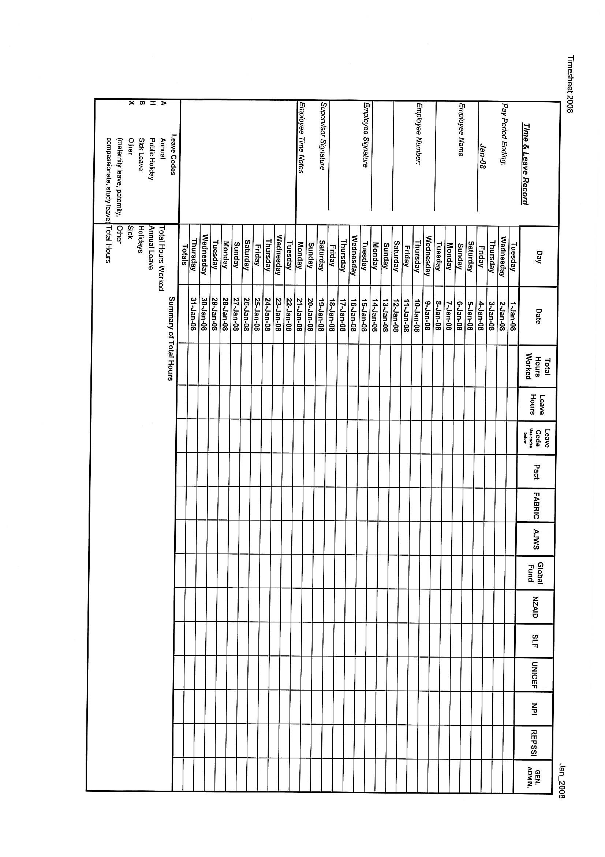

Appendix 9: Salary Sheet/Labor Distribution Sheet

 |  |  |  |  |  |  | SALARY SHEET
Office: |  |  |  |  | Currency: |  |  |  |  |  |  | Month:
Gross Pay | Allowances |  |  | Deductions |  |  | Other | Net Pay | Funder Allocation (Based on T/S) |  |  | Name | Signature
 |  |  |  | Tax |  |  |  |  | %  Funder 1 | %  Funder 2 | %  Funder 3
Prepared By: |  |  |  | Reviewed By: |  |  |  | Authorized By: |  |  |  | Paid By:
Date: |  |  |  | Date: |  |  |  | Date: |  |  |  | Date:

Appendix 10: Request for Travel Advance

To:
From:
Location:
Date:

Please issue a travel advance as indicated below:

Advance to: |  | Employee Non-Employee

If traveler is NOT employee, fill out this information.
SSN: |  | If NOT Citizen/Resident, check here.
Mailing Address:

Advance Amount: |  | Account #:
Contract #: |  | Project #:
Project Name:
Destination:
Purpose of Trip:

Departure Date: |  | Return Date:
Calculations for Advance:

Approved by Project Director

Note: Please request advance no less than (insert number) working days prior to date check is needed.

Appendix 11: Travel Expense Reimbursement Form
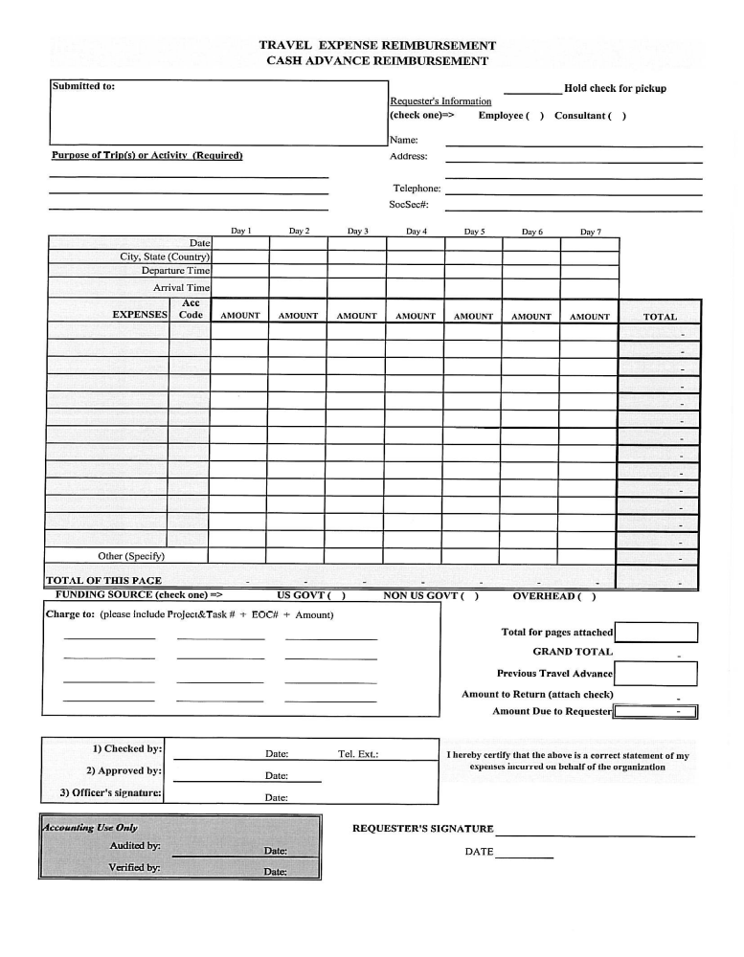

Appendix 12: Inventory/Fixed Asset Register
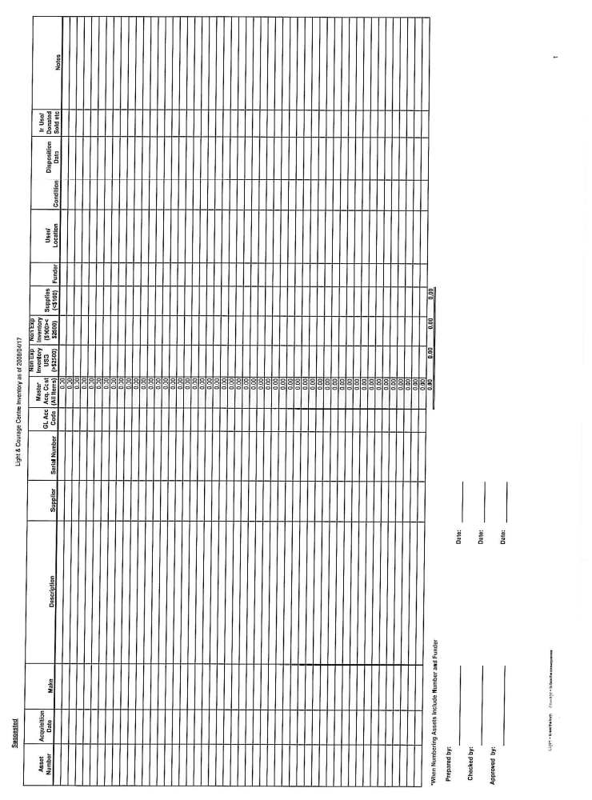

Appendix 13: Consultants Work Order

Consultant Work Order
[Consultant Name]
Work Order No. [Project Number – Task Number (if applicable) – Assignment Number]

Period of performance:

Task Description:

Deliverables/Milestones Due Dates

1.
2.
3.

Payment Schedule:

- Fixed price payments based on completion and acceptance of deliverables/milestones

-or-

- Not to exceed level of effort (number of days) with payments based on days worked and days worked tied to specific progress in achieving milestones/deliverables

Expenses:

Technical Direction:

PREVENT and Consultant agree that the above services will be provided in accordance with the PREVENT Consulting Agreement signed by both parties dated .

For PREVENT Consultant

Signature Date Signature Date

Name Name

Title Social Security Number

Small Business Certifications: ____Woman-Owned: _____ Disadvantaged (certification no.)

Appendix 14: Consultant Scope of Work

SCOPE OF WORK
[TYPE/NAME OF CONSULTANCY]
[ORGANIZATION NAME]

BACKGROUND OF ORGANIZATION/PROGRAM:

PURPOSE OF CONSULTANCY:
OBJECTIVES OF CONSULTANCY:
The objective of the [Type/Name of consultancy] will be to:

EXPRESSIONS OF INTEREST:

Consultants or firms interested in participating with this project are asked to submit a proposal, their resumes with qualifications, as well as a completed bio-data / 1420 form (provided) for review.

TERMS OF REFERENCE:
The services to be provided are as follows:
Deliverables | Date

BID FORMAT:

The response should be submitted in the following format:

Short Introduction Summary | Covering the review of the terns of reference and clear understanding of the consultancy requirements.
Methodology | Covering the proposed approach, main technical proposal including work tasks and time estimates for various activities.
Statement Of Capability | Bidders should include a statement of capability that details the level of resources available within the organisation to deliver the services requested. This should also include the number of trained personnel, their experience and qualifications.
Time Schedule/Project Plan | A proposed time schedule showing each specific task with clear time estimates.
Financial Proposal | Detail the consultant’s financial proposal and the pricing should include required transportation costs for travel.

GENERAL CONDITIONS OF BID:

- An electronic copy of the bid in MS Office templates should be submitted electronically to PREVENT at the following addresses no later than [due date and time]:

- [Address for bids to be sent]

- All documents produced will be the property of PREVENT

- Documents are to be produced in [insert language], must use the Microsoft Office Suite software, and must be submitted in electronic and hard copy forms.

- The currency for bidding and payment shall be in [insert currency]. The pricing will remain fixed throughout the duration of the Contract and should [include/exclude] VAT.

Technical Direction:

[Name of person responsible] will be responsible for technical direction of consultancy and will oversee the consultant.

PAYMENT TERMS:

The Consultant will invoice PREVENT upon the [Name of person responsible for technical direction] acceptance of the deliverables. The Consultant will invoice PREVENT not more often than weekly and not less often than once every 15 days.

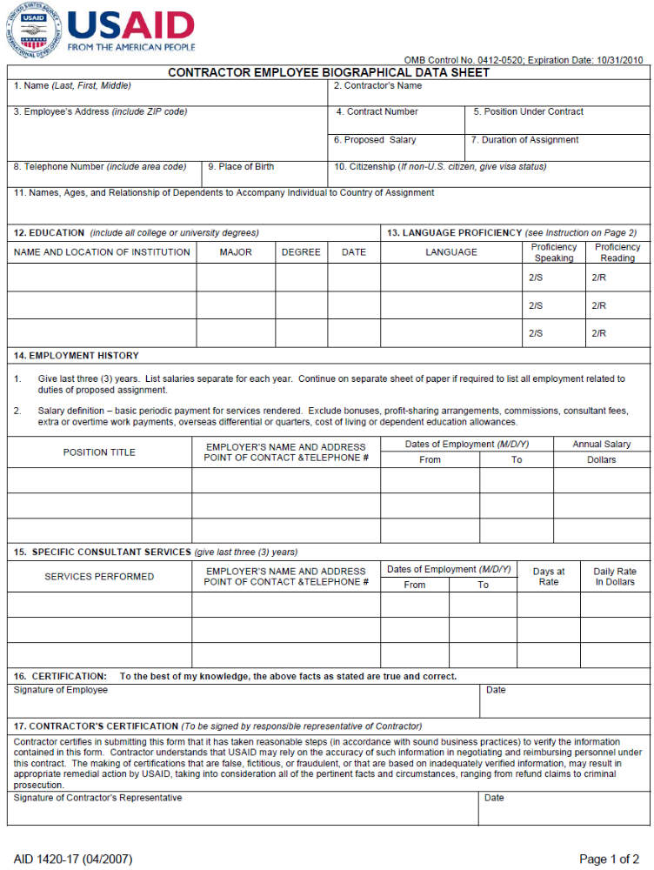
Appendix 15: 1420 Bio-Data Form
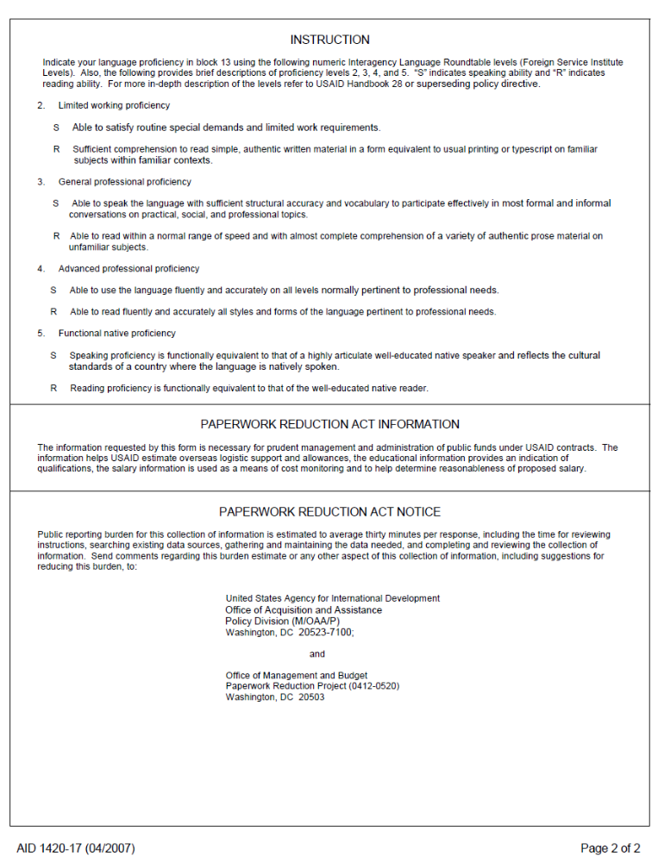
Appendix 16: Consultant Fee Payment Request

FEE PAYMENT REQUEST

Submitted To: Pay To:

PREVENT
Street Address
City, Country
Attention:

Project No.: _________________________

Project Title: _____________________ ________ SS# _______________
Date: ____________________________

Brief Description of Work Performed/Deliverables Submitted:.

Dates Worked:

Total Days: __ (if applicable)

Payment Requested: $ ______

I hereby certify that this request for payment is an accurate statement of my hours/days worked on the above indicated project, that this request does not violate any federal, state or local laws or regulations and is in accordance with the terms and conditions of my Consulting Agreement with PREVENT.

Consultant Signature: ____________________________________

Small Business Certifications: Woman-owned: __________
Small Disadvantaged (provide certification#): __ ___

I hereby certify that I have reviewed this request for payment and that it is an accurate statement of the hours/days worked and the performance as stated above.

Project/Technical Director Signature: _____________________________

Project/Job #: ______ ___

Payment Amount: _____ _____________

Outstanding Advance: _

Net Pay

Special Instructions: ________

Prepared by: ______________________ Date: __________________

Reviewed by: _________________________ Date: _________________
(Finance Staff or Business Manager)

